A Universal Assembly Language and Compiler Framework

Introduction
Ever since digital computers have been invented, people have been trying to make them more user-friendly. At the core of any digital computing system; is a digital central processing unit (CPU). In modern computers, the CPU has a job that can be defined simply as fetching machine-readable instructions, parsing the instruction using hardwired logic units, and finally executing the instruction by sending electrical signals to the appropriate components of the computer. This model of computing; though simple and easy to understand, can make using computers time-consuming and cumbersome. Manually creating machine-level instructions in binary can be a time-consuming, and repetitive process -- the kind of process that computers themselves were designed to solve, so computer programs called compilers were invented to make programming computing systems less time-consuming and repetitive, and increasing developer productivity through abstractions that a typical person can understand.
The basic principle of a compiler; is to create a program that translates high-level instructions that are readable to a human, into binary machine instructions which are readable to a computer. With a compiler; it is possible to provide inputs to a program in a text-based format, rather than inputting a series of ones and zeroes that are directly parseable by the CPU.
However; a compiler which translates directly from a high-level language (such as assembly languages, C, C++, etc.), must inherently be CPU and platform specific. Each CPU has its own unique set of instructions; which makes it difficult for one to write a compiler (and as a result, a computer program) that is capable of running on many different types of computing platforms. Even if we ignore the differences in CPU architecture, there are still vast differences in peripherals, available memory, and compatibility with other software and hardware on the system that need to be accounted for. To solve this problem; numerous companies have developed intermediate assembly languages, and managed programming languages, such as C#, Java, Visual Basic, etc. Compilers written for these languages do not translate from the high level language directly to CPU instructions; but instead, produce an intermediate assembly format which is readable by another compiler at runtime (which is CPU specific, but isn’t as complicated as the original high-level language compiler); or is simply executed on a simulated CPU that can understand these instructions. Such virtual assembly languages allow for greater degrees of abstraction, and separation of concerns between a language designer and a systems engineer. The language designer only needs to know how to convert from their language to the abstracted assembly language, and the systems engineer only needs to be concerned with the conversion from virtual assembly code, to machine instructions; without having to worry about the higher-level languages that are generating these instructions.
However; a common problem with these high-level assembly languages is that a tremendous amount of metadata must be provided with the assembly, such as method names, class names, and other information which has no meaning at the runtime of the application. A primary concern in developing these high-level assembly languages has been simplicity, not conciseness. Additionally; to abstract away from the underlying hardware, vast libraries such as the .NET framework and the Java Virtual Machine have been invented; which consume large amounts of system resources, and are not ideal for high-performance applications, or embedded systems. In many embedded systems and high-performance applications; speed and compactness are priorities over speed of development. This is by necessity -- since embedded systems typically have less than 1 megabyte of memory, and high-performance applications cannot tolerate the high latency caused by garbage collection and interpretation of managed instructions. Therefore; I believe that managed assembly languages should be more compact, have faster garbage collection (as well as the ability to opt-out of garbage collection in certain cases), and rely less on bulky runtime libraries.
As a solution; I propose a new assembly language designed for compactness and speed, as well as a runtime environment consisting of a minimal set of instructions needed to get the job done, well at the same time decreasing the size of a compiled executable file.

Universal Intermediate Language

Runtime environment
The runtime environment will consist of a program interpreter, which will read in intermediate language instructions (tokens expressed in binary form which is not intended to be human-readable) and translate them to machine-specific assembly instructions. It will also include a garbage collector to manage platform memory, and a minimal standard library of instructions for interfacing with the outside environment. Unlike previous attempts at making a universal assembly language, the standard instructions will be minimal, and will exist only for the purposes of creating a turing-complete internal environment, as well as providing a foreign-function interface to the external environment, allowing the system to be extended to support platform-specific I/O operations. For the first phase of this project, a simple interpreter shall be sufficient. For the second phase, it will be expected to not only be able to interpret and execute instructions, but also to convert them to native assembly code.

Assembly language
The assembly language format will be derived from the MSIL (Microsoft Intermediate Language) specification. However; the OPCODES will be changed, as well as the OPCODE structure. Each OPCODE will be a variable-length compressed integer, to decrease the size of the executable file, and parameters to instructions shall be of fixed size (in most cases). A lookup table will be provided at the start of each executable file for resolving global values; in contrast to existing IL formats which allow for strings and method information to be specified directly in the instruction. This should be able to remove duplicate information from the IL bytecode, making the resultant executable more compact. As a derivative of MSIL; valid MSIL code should be translatable to UIL code, with the exception of DLR (dynamic language runtime) components.

Compiler
The initial compiler shall be able to convert from MSIL code to UIL code. The input provided to the compiler shall be a valid MSIL assembly file, and the output shall be a UIL assembly file. The UIL file shall consist of all the metadata, and UIL assembly necessary to execute the program in either a scripted (interpreted) fashion, or re-compiled to a machine’s native assembly format. The resulting UIL assembly code may include references to other UIL files; which are not necessary to include in the resulting binary, and may be distributed separately as individual program components.

MSIL vs. LLVM bytecode

MSIL
MSIL is Microsoft Intermediate Language. The core principal behind MSIL was to create a pseudo-assembly language that mimics the functionality of a high-level language. MSIL contains many of the capabilities of high-level managed languages, such as C#, Java, F#, VB.NET, etc. MSIL allows language designers to focus on writing compilers that emit IL, and optimize for the .NET virtual machine, without having to worry about machine-level optimizations, or complex translations to native assembly language. Since MSIL closely mirrors a high-level language; it is relatively easy to emit IL code from a C#, Java, or VB.NET compiler.

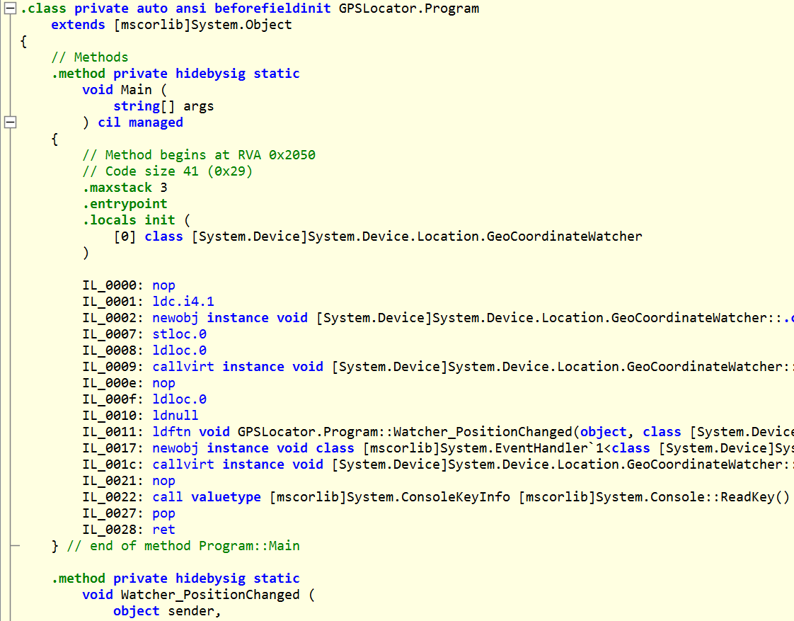

LLVM bytecode
LLVM bytecode was designed to provide a universal, low-level assembly format that would be directly and easily convertible to native assembly code on a variety of platforms. LLVM bytecode is not intended to be used for creating an intermediate assembly format; instead, it is designed to merely serve as one layer among many in the compilation and linking process, and to allow the porting of languages to different platforms without having to worry too much about modifying the language-specific compilers. LLVM bytecode closely mimics “real” machine assembly language, although it does provide a few high-level constructs such as variable names, functions, and basic integer types --- Some CPU architectures may also have specific LLVM “Intrinsics” which need to be taken into account when generating LLVM IR (LLVM bytecode) for that architecture:
target datalayout = "e-m:e-i64:64-f80:128-n8:16:32:64-S128"
target triple = "x86_64-ellcc-linux"
@.str = private unnamed_addr constant [44 x i8] c"Hello world! I C you entered %i args today!\00", align 1
; Function Attrs: nounwind
define i32 @main(i32 %ac, i8** %av) #0 {
entry:
%ac.addr = alloca i32, align 4
%av.addr = alloca i8**, align 8
store i32 %ac, i32* %ac.addr, align 4
store i8** %av, i8*** %av.addr, align 8
%0 = load i32, i32* %ac.addr, align 4
%call = call i32 (i8*, ...) @printf(i8* getelementptr inbounds ([44 x i8], [44 x i8]* @.str, i32 0, i32 0), i32 %0)
ret i32 0
}
declare i32 @printf(i8*, ...) #1
attributes #0 = { nounwind "less-precise-fpmad"="false" "no-frame-pointer-elim"="true" "no-frame-pointer-elim-non-leaf" "no-infs-fp-math"="false" "no-nans-fp-math"="false" "stack-protector-buffer-size"="8" "target-cpu"="x86-64" "target-features"="+sse3" "unsafe-fp-math"="false" "use-soft-float"="false" }
attributes #1 = { "less-precise-fpmad"="false" "no-frame-pointer-elim"="true" "no-frame-pointer-elim-non-leaf" "no-infs-fp-math"="false" "no-nans-fp-math"="false" "stack-protector-buffer-size"="8" "target-cpu"="x86-64" "target-features"="+sse3" "unsafe-fp-math"="false" "use-soft-float"="false" }

Proposed MSIL target: Most recent MONO release

The native (bootstrap) compiler will be written in C# with Mono; in order to preserve compatibility with systems that many people at school use (MACs in particular); the compiler will be written on an Ubuntu Linux x86_64 system running Mono.
The runtime will be written in the native language of each targetted platform. On Linux; this would be C/C++; on MAC this would be Objective-C, on Windows this would be C++/CLI, on web; this would be LLVM/C++/JavaScript.

Platform-specific code/implementation

Runtime (initial implementation)
The initial runtime will consist of a garbage collector, a basic ABI, and a UAL interpreter. The first component to build will be the garbage collector. The garbage collector will be implemented in a similar manner to the existing .NET garbage collector; however, to make it workable on embedded microcontrollers, it will have to be substantially simplified and re-architected.

Garbage Collection
The garbage collector shall be a multi-generation, compact-sweep garbage collector. The garbage collector’s memory buffer will start at a memory address aligned to the word size of the CPU. All generations will be initialized to a fixed memory amount at startup. If a given generation runs out of memory, and the platform supports it, the memory pool for that generation may be re-initialized to a larger size at a later time.

Memory pool -- Allocation block format
The memory pool of each generation shall consist of blocks, whose size and address are aligned to the word size of the host CPU. Each block shall contain the following information:

Allocation header
- Total size of memory region (including this header)
- Pointer to data segment of memory region (contained for fast lookup purposes)
- Number of pointers in list (if this is 0, the object can be assumed to be “free space”)
- List of pointers to this object
  - This list is used during the compact phase, when it is necessary to move objects around in memory to compact the garbage-collected heap.

Allocation process (void GC_Allocate(void* gc, size_t sz, void** output))
- GC_Allocate will ensure that there are at least sz+sizeof(header) (aligned to CPU word size bytes) bytes available in the generation 0 pool, by checking if the total allocation size (sz+sizeof(header) (aligned to CPU word size bytes)) is less than or equal to the available space (genSz-marker, where genSz is the size of the memory allocated from the OS to the GC pool, and marker is the break between allocated and free memory pages, in bytes)
  - If enough space is available, simply increment the marker by the desired allocation size, update the chunk metadata to point to output (as an initial pointer), and set *output = the memory location for the newly allocated block.
  - If there is not enough space available, initiate the compaction process. If there is enough space, just run the allocate function again.
    - If there is not enough space available (even after compaction), but it is possible to call realloc to increase the size of the memory pool, realloc the memory buffer (increasing its size by a factor of 2), go through all pointers in the pool and update them to their new address, and attempt the allocation process again (or on multi-threaded systems, it may be beneficial to defer the allocation here and yield to another thread, but our initial iteration will be designed for only a single-threaded runtime anyways, so we don’t have to worry about that right now; .NET does a whole bunch of weird stuff when it has to increase its pool size).
- At the end of the allocation process; if it succeeded, increment the liveObjectCount

De-allocation process (void GC_Unmark(void* gc, void** ptr))
- When a child object falls out of the scope of its parent, it is necessary to call GC_Unmark. GC_Unmark will find the generation that the object belongs to, and remove the corresponding pointer from its pointer table. If the object has no pointers left in its table, decrement liveObjectCount
  - If liveObjectCount is now zero, set the marker to 0 as if a Compact phase had just occurred.

Compaction process
The memory compactor will walk through all memory chunks, and do the following for each chunk:
- If there are no pointers in the pointer table, the object is free space and can be reclaimed at this point
  - Move all memory blocks to the right of this segment over to the left by one block

